**SYSTEM DRAFT PLANNING**

@Arkiollezan

**mARK**|**rIO**|**bryLLE**|**mienZAN**

**Home (Main Page) |File: index.php**

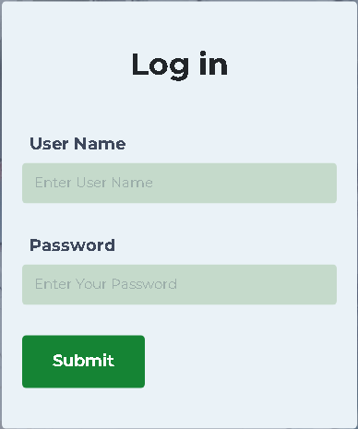

Services offered by the Nurse 2 (icon with label-concise)

Services offered by the Nurse 1 (icon with label-concise)

A Premier, Multidisciplinary, Technological University.

**CEBU TECHNOLOGICAL UNIVERSITY**

**Naga Extension Campus**

AVAILABLE MEDICINES

CONSULT US

HOME

**“Consult Us” Tab (Second Page) |File: index.php**

**Dapat naay separate form ang student and walk-in patient**

**IMPORTANT REMINDER**

**Kung unsa’y ma-input dinhi, kinahanglan nga mu-appear sad didto sa admin nga page (consultation.php)**

**IMPORTANT REMINDER**

**Kinahanglan maghimo ug database para sa walk-in patients**

**Colors and design of this form & page is not final, it is only an example for better understanding.**

**IMPORTANT REMINDER**

**Dapat masend and data sa patient didto sa admin**

**(consultation.php)**

**CANCEL**

**SUBMIT**

**Course/Year/Section**

**Complain(s)**

**Age/Sex**

**Name**

**Date and Time**

**Consult us.**

**“Available Medicine” Tab (Third Page) |File: index.php**